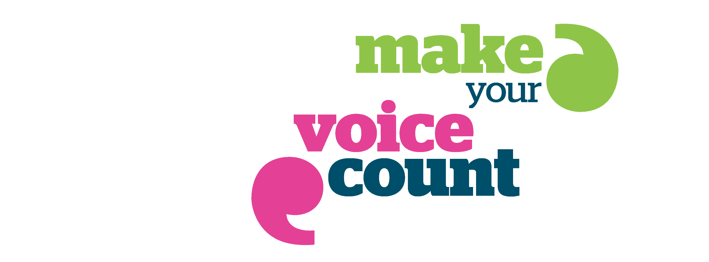


A REPORT ON THE VIEWS AND EXPERIENCES OF CHILDREN, YOUNG PEOPLE AND FAMILIES OF HEALTH AND SOCIAL CARE IN NORTHAMPTONSHIRE – JUNE 2014

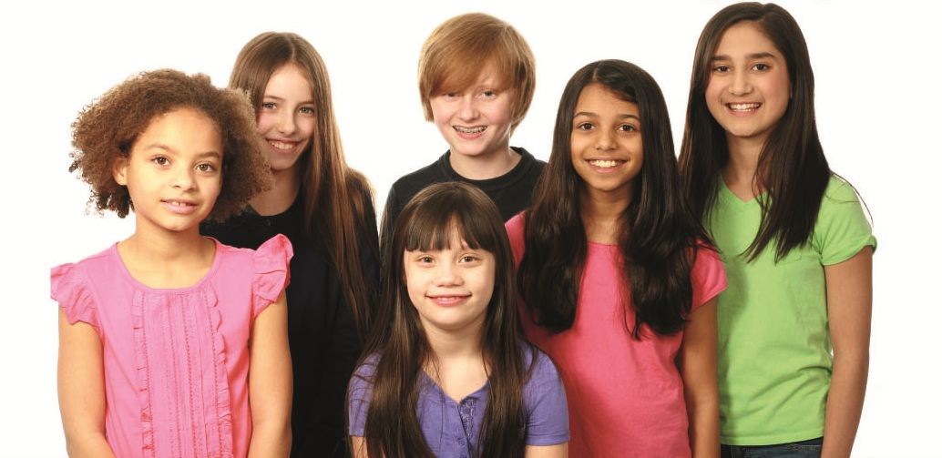

Healthwatch Northamptonshire is the independent consumer champion for people who use, or could use, health and social care. Established in April 2013, our aim is to gather the views and experience of patients, service users, carers and the wider public. We will report these views and experiences to health and social care decision makers to influence and improve the quality of care. Our vision is to make a positive difference to the quality of care and improve health and wellbeing in the County.
If you would like more information about this report; the work of Healthwatch Northamptonshire and how to get involved please email enquiries@healthwatchnorthamptonshire.co.uk reference: Children and Young People or ring us on 01604 893636.

Summary of findings

The two local clinical commissioning groups (Nene and Corby) plan to improve children’s community health services. Clinical Commissioning Groups (CCGs) buy (or commission) the majority of health services for the local population. The commissioning groups are working to improve child and adolescent mental health and emotional wellbeing services; services for children with complex care needs and services for children with special education needs and disability. Originally, the CCGs intended to recommission services from 1 October 2014. This plan has changed and the timescale on the redesign has been extended. Healthwatch Northamptonshire wanted to ensure that the views of children, young people and families were gathered and heard through the redesign exercise and that these views positively influenced any changes. We have gathered views and experiences through a survey; discussion groups; attending meetings and talking individually to children, young people and families as well as health and social care professionals. We have done this to add to the engagement activity undertaken by the clinical commissioning groups. This report will be widely circulated to inform improvements in services. We intend to add to our knowledge of the views and experiences, by expanding our engagement with children, young people and families.

The key themes we heard during the consultation were:

- many children and young people don’t get the right support at the right time. Several young people and parents described the “struggles” or “fights” they have had to get services. Many people talked about the high level of need they have to demonstrate in order to get any support. The impact this has on the lives and wellbeing of children, young people and families is significant, at times overwhelming, and makes it difficult to plan for independence. One advocate explained that this is life-limiting in the long term. A list of factors were highlighted by people who gave us their views:

  - lack of continuity of care between different services
  - lack of continuity in the transition to adult services
  - lack of professional time or perceived commitment, interest and sensitivity on the part of professionals
  - gatekeepers/criteria which block or limit access to services
  - services being inaccessible
  - weak partnership working with some ethnic minority groups and organisations. Difficulty accessing the right services for children with complex behavioural issues
  - lack of information on support available – not knowing where to go to get support was a recurrent theme
  - inadequate social support to prevent crisis or deterioration
  - long waiting times for services during which time the child/young person’s health and wellbeing can decline
  - lack of meaningful involvement in service design. A representative explained that young people, who had been asked to gather the views of their peers, didn’t feel listened to when they had gathered views and made recommendations for service improvement.

- there are concerns about health transitions for young people moving from child health services to adult services. The fears are that the trust and competence built between families and paediatricians would be lost. There are anxieties about continuity of care and a consistency in the level of support, as young people become more reliant on social care
- many families talked to us about a lack of co-ordination of services between health, social care and education to meet the needs of families of children with complex needs

- there are concerns about the availability of social work support. One foster family was waiting to be allocated their third social worker within 12 months. Families talked about the impact on continuity of care due to turnover in staff

- we heard widespread concern about the limited availability of Child and Adolescent Mental Health Service. People said CAMHS (Children and Adolescent Mental Health Services) are usually good, but the issue is access. Many people said that waiting times for CAMHS are unacceptable. This was a view echoed by nearly all the children and young people who spoke to us about CAMHS. Children and young people said the service wasn’t always consistent. One family reported that they had been advised by CAMHS to call the police if their child with autism displayed particularly challenging behaviour. The family were then offered behaviour management support, which wasn’t effective, while they waited for advice and medication from a CAMHS consultant

- access to counselling services is an issue. Some children and young people aren’t aware of whom to go to. The report includes examples of children and young people with urgent needs who were turned down or didn’t have their calls followed up. We heard from one young woman who had 12 counsellors in 4 years, while other young people raised the need for general knowledge and awareness around self-harm and sexual health

- there were concerns about the variations in assessments in child protection and diagnosis across health and social care organisations. Some families felt that generic social work teams weren’t knowledgeable about the health needs and risks to children with disabilities. For example, a carer was concerned about varying professional responses to bruising on a child with physical and complex needs. Some had raised it as a safeguarding issue, while others said it was expected for a child with complex and physical health needs. Families of children with autism said they had experienced a varied range of processes and diagnostic practices from varied agencies and providers and families weren’t signposted to other appropriate services where there wasn’t a diagnosis. One local advocate had concerns that NICE guidelines were not being followed with regard to the diagnosis of ASD, with varying practices within the county

- universal and tiered training to support children and young people with Autism Spectrum Disorder (ASD) is an issue. Representatives and parents gave examples of the need for more awareness within all agencies

- there is concern about the quality of health and wellbeing support within schools. One counselling provider wanted better relationships between school nurses and community and voluntary counselling agencies in order to maintain continuity in school holidays

- there are questions about the scope of advocacy for young people aged 16-18 in both health and social care

- the short-term nature of service provision and the lack of contracts with service users is a cause for concern. The carer of a young adult with autism believes that respite services providers, especially private providers, can terminate contracts at any time and that ‘gatekeepers’ try to prevent access. The parent of a user of Delos Care is worried that their son won’t be eligible when they have to reapply and they need longer-term support

The main themes arising are included in the body of the report. Survey responses included:

- 36% of people said they found the services they were using to be very helpful 32% said services were OK, 21% said services were not helpful. (11% didn’t answer)
- 43% of people surveyed said they need more support. These included a range of responses from “real help” to responsiveness in services, emotional support and signposting among others
- 43% of people had found it difficult to get support
- Staff were identified as the most appreciated part of services - in 43% of responses to the survey

Positive feedback

During the course of our engagement activity, we also heard some positive views about how services do meet need:

- children, young people and families appreciated staff who took time to explain things
- staff who made children and young people feel relaxed
- organisations with clear rules about confidentiality
- staff who engaged children during appointments
- good information and signposting
- good social and emotional support
- “feeling listened to” and being treated as an individual
- co-ordinated care and support
- friendly and hard-working staff

Summary of recommendations

- ensure clear and easily accessible information on mental health support for Looked After Children
- a whole system approach to mental health and wellbeing of children and young people, which can demonstrate that young people won’t fall through the net
- services equipped to deal with adolescent mental health and challenging behaviour
- involve service users more
- ensure staff are equipped to meet the needs of children with Autism Spectrum Disorder (ASD) and know how to identify triggers
- families wanted to know how the early help model will work for children with ASD
- families wanted to know what the Step up and Step down services would actually be
- NHS providers, Education Health and Care planning and Social Care Transitions services should work together
- ensuring stronger links between statutory and voluntary sector agencies
- ensure more local activities
- ensure activities for children with higher levels of need
- give clear recommendations in service specifications about the training and standards required from providers model to ensure staff have the right attitude, skill and capability to support children’s needs
- “shorter waiting times”
- “more knowledgeable and pro-active staff who take action”
- one service user appreciated a text service
- “a named person who knows how to provide continuity of care”.
- not having to start again
- assessments to include meeting children or observing them as it is felt decisions are made without really knowing the children concerned
- ensure availability of more knowledgeable and proactive staff and ensure providers adhere to guidelines
- services which genuinely focus on improved health and social care outcomes
- “assessments should include meeting the child as some decisions are based on paperwork”
- gatekeepers should work in partnership with families and listen to what they have to say as they know their child’s needs. It could drive down costs and increase knowledge to provide for similar needs
- paediatricians to be aware of the requirements for assessment and demonstrate full participation with education and social care staff, through writing of advice and representation at meetings where possible
- individual schools should not be named by professionals as the suitable placement for a child/young person during the assessment process
- Education, Care and Health assessments should be multi-disciplinary and include the views of children, young people and families
- education, health and care staff to be encouraged to monitor issues which prevent full participation from education, health and care staff
- “young people moving into adult services should have a wellness plan”

Methods of engagement with children, young people and families – gathering our evidence
Since early October, Healthwatch Northamptonshire has:

- attended a range of events to hear the views and experiences of children, young people and families
- talked to health and social care professionals around the County who work with children, young people and families
- surveyed children, young people and families – through a paper survey and via the Healthwatch Northamptonshire website, Twitter and Facebook. 53 surveys were completed. The survey is attached as Appendix 1
- held focus groups with families and young people at Time 4 Support, Dreams Youth Café and New Ark Foundation
- circulated information about the recommissioning plans to local communities including schools, early year’s settings, children’s centres and GP surgeries
- shared information with various organisations and agencies that have posted it on their websites and publicised our engagement activities through Facebook, Twitter and other media. These include: East Northamptonshire District Council , Northampton Borough Youth Forum, BBC Radio Northamptonshire, Inspiration FM, Northamptonshire School’s Bulletin, Northamptonshire Parent Forum, Time for Support Parent Group, Northamptonshire early years and children’s centres bulletins, Deaf Connect and Northamptonshire Early Help Fora. Information was sent to all schools in Northamptonshire

Other evidence:

- Healthwatch Northamptonshire ran a general engagement campaign during September 2013 to talk to local people about Healthwatch and find out views about local services. Views and experiences about services for children, young people and families are included in this report.
- since May 2013, Healthwatch Northamptonshire has collected information received from people phoning or emailing our enquiries line. Views and experiences about services for children, young people and families are included in this report

In addition to the survey and information circulated to schools, early years’ settings and children’s centres, we spoke to and heard from a number of local groups and organisation, these included:

Joint Healthwatch Northamptonshire and the Northamptonshire Association of Youth Clubs: (Additional Needs Groups) Mix it Up event (this included activities such as messy play and roller skating)
Northamptonshire Children and Young People’s Partnership Shadow Board
Northampton Youth Forum
Corby Dreams Youth Cafe
Northamptonshire Young Carers
Northampton Lesbian, Gay, Bisexual and Transgender Forum
Northampton Sikhs: Women’s Day
Northamptonshire County Council Transitions Event Young People and Carers
Time 4 Support parent group
Northamptonshire Special Educational Needs and Disability Pathfinder
Northamptonshire Early Help Forums
New Ark Foundation BME group
East Northamptonshire Council
Zimwomen: Young Black Achievers Event
Deaf Connect
Northamptonshire Parent Forum Group
Northampton Disabled People’s Forum
Healthwatch Volunteers
Northampton Bangladeshi Association
Northamptonshire Foster Carers Association
Healthwatch Children, Young People and Families Working Group
Northamptonshire school leads
Home Start
Northampton Education and Youth service

Views, experiences and questions by themes, with recommendations for change:

Feedback covered a range of wellbeing and service delivery areas. The people we spoke to had many questions about the recommissioning proposals and wanted to be reassured that the redesign would make services better and that early help would be available in a range of situations.

Mental health

Children, young people and families reported:

- perceptions of long waiting lists
- not enough access to high quality support and preventative services
- mental health services which seems to penalise children and young people for serious symptoms, for example, by being excluded from school for behaviours symptomatic of Autism Spectrum Disorder (ASD). There was a perception that other services such as specialist Child and Adult Mental Health Services (CAMHS) don’t appear to have a wide enough reach to meet the needs of children and that they weren’t always able to take a holistic approach with regard to educational and social elements of children’s lives. This allowed those aspects to suffer
- children having to go through the teacher to see a school nurse, they didn’t want to have to talk about issues to teachers
- police not having a general awareness of mental and emotional wellbeing of children and young people
- having to seek diagnosis privately
“Everywhere I go there is a long waiting list and it’s hard to cope with when I am suffering from depression”
“My mum contacted [serious assault counselling service] but they didn’t get back to us” the young person then went without counselling for two years
“When I asked to get a different counsellor they sent me to xxxx. I didn’t get a proper counsellor, so I left.”
- fear that the implementation of Common Assessment Framework (CAF) to access services will be a barrier to asking for help as some young people already struggle to come forward, they test with a low level presenting issue, and “won’t consent to it all written down in black and white”
- children with complex needs have had to wait up to three months for a crisis response, during which time school and family life deteriorates
- unfair withdrawal/cessation of services
- children and young people could continue to fall through the net

Recommendations for change

When we asked what decision makers could do to help, responses included:

- ensure clear and easily accessible information on mental health support for Looked After Children
- a whole system approach to mental health and wellbeing of children and young people, which can demonstrate that young people won’t fall through the net
- services equipped to deal with adolescent mental health and challenging behaviour
- involve service users more

Autism Spectrum Disorder (ASD)

Issues:

- inconsistency in awareness in schools
- people warn that the most vulnerable families can’t cope with the stress of having to fight so hard to get support
- families were concerned that children with ASD currently fall through the net.
- there was specific concern about inconsistency in school support and management of ASD and that children are expelled from school because of challenging behaviour
- parents felt schools give up on children with challenging behaviour and complex needs
- clarity was sought on whether schools have a responsibility for children who could as a result, be out of school for up to a whole year.
- families have to exaggerate needs and concerns to get any service, which works against preparation for independence and life chances. They wanted to know how the new model would stop this

Recommendations for change

- ensure staff are equipped to meet the needs of children with ASD and know how to identify triggers
- families wanted to know how the early help model will work for children with ASD
- families wanted to know what the Step up and Step down services would actually be

Accessibility of services

Children, young people, families and representatives told us:

- location: they preferred convenient local services
- services “who only have email addresses” were difficult to get hold of and took a long time to get back to service users, including the Early Help Team.
- opening times of services are not always appropriate – including a child counselling service opened for two mornings a week.
- Children, Young People and Families asked how the new model would be different and ensure early help at every stage
- crisis responses are reported to be delayed and in general CAMHS support is reported to be slow, how will the new model meet the demands in Northamptonshire and is there an estimated population per LOT?

Case study 1
Tom is 16 and was diagnosed with Autistic Spectrum Disorder (ASD) as a young child. Tom lives with his mum Sam and they are supported by Tom’s grandparents. Sam explained that when Tom began puberty at 12: “it was as if he just couldn’t contain himself”. The family tried to get more support as they felt his ASD symptoms were out of control.
18 months ago Tom was excluded from school because of his behaviour. Tom was then referred to CAMHS for support and asked to see an anger management therapist. The family felt this wasn’t working and had to push for an appointment with the CAMHS doctor, which they received after six months. During this time they could not access crisis care and were told by staff to ring the police to respond to Tom’s challenging behaviour. Once Tom was on the medication prescribed his anger management therapy worked well. By the time the medication and support was in place and Tom was able to go back to school, he had been without schooling for 8 months.
Tom’s family had to search for a school for Tom as the centres he had previously been sent to could not cope with his behaviour. They tried several schools, including those recommended by the Council, but felt that staff were not competent enough to look after children with ASD. They felt that that all schools identified as “for children with disability” weren’t always competent and many only catered for children with less challenging needs.
Sam finally found a school for Tom, which turned out to be a previous respite care provider. As Sam had frequently been called to collect Tom from school and respite care because of his behaviour, Tom ended up using one service for both schooling and respite, this meant Tom could not get any real respite care because he had already been there for normal schooling. However, Tom was excluded again for typical autistic behaviour
Sam explained that it was exhausting to have to fight for support, constantly wait for meetings and assessments and be turned away from services who were supposed to provide a service. She also explained that she felt lucky to finally have a good service and that without the support of her own parents she wouldn’t have been able to cope.
Sam wants to know why Tom had to wait so long to see the appropriate practitioner, why schools and respite services appear to “cherry-pick” the children who will be the least hassle and why so many services are inequitable, which includes penalising children with exclusion for behaviours which are symptoms of their condition. Sam would like decision-makers to understand the long term impacts of this on Tom’s education and the family’s wellbeing.
“Tom is a child with a condition. He didn’t do anything to deserve ASD; we should be entitled to the same education and quality of life as non-disabled children and families”. Sam – Tom’s mum

Coordination of support for disabled children and their families

Issues:

- not having a care plan
- lack of information-sharing between services
- difficulty accessing information
- long waiting lists
- lack of understanding about needs of families including pressures and stresses
- lack of commitment to help
- when asked what made access to the currently used services difficult responses included:

“Services aren’t all combined, nobody knows about everything. It’s hard to get hold of information” “gate-keepers not wanting you to have anything, you are made to feel guilty for asking” this was a view shared by many families. One professional included: “…general lack of understanding of how to engage voluntary community agency professionals”

Recommendations for change:

- NHS providers, Education Health and Care planning and Social Care Transitions services should work together
- ensuring stronger links between statutory and voluntary sector agencies

Social Activities and Respite Care

Children, young people and families reported:

- appreciation of stimulating social activities with interaction and opportunities to learn skills for independence

Concerns:

- available play activities were more suited to children without complex needs
- children with challenging behaviour reportedly have their respite care terminated on occasions. This adds to family pressure
- parents are unhappy with lack of clear professional responsibility for co-ordination of care and limited understanding of physical conditions
- lack of good quality play schemes for children with disabilities resulting in overcrowding. One parent felt this was causing safety hazards at a Local Authority recommended scheme which they alleged is not being monitored
- concerns about lack of adherence to NICE guidelines by respite care providers
- “cherry-picking” by respite services as there are overarching services for “disability” while the needs for ASD are very different to Downs Syndrome and can be challenging

Recommendations for change:

- ensure more local activities
- ensure activities for children with higher levels of need
- give clear recommendations in service specifications about the training and standards required from providers to ensure staff have the right attitude skill and capability to support children’s needs

Access to assessments, support and care

Children, young people and families reported:

- easy access when arranged by one professional
- fatigue when having to make a lot of effort to be assessed, and a feeling of wasted time when not eligible
- no clear pathways for care
- lack of clear information on help available

Comments included:

- “being pushed from pillar to post”
- “It took me a year to get anywhere and I had to go private to get my diagnosis for ASD otherwise it wouldn't have happened”

Recommendations for change:

- “shorter waiting times”
- “more knowledgeable and pro-active staff who take action”
- one service user appreciated a text service

Care pathways

Children, young people and families told us:

- they didn’t like starting all over again when needs changed
- they expected professionals and agencies to know that needs fluctuate and to plan accordingly
- they didn’t know where to go to get help and were left without a service when their condition fluctuated

Questions:

- will there be a requirement for all providers to ensure staff attend Making Children Safer training, or similar training to enable use of the CAF and to promote interagency working?
- how will the new arrangement ensure a commitment to use of CAF or alternative
- will the Early Help teams have highly skilled staff to co-ordinate prevention of crisis and exclusion from school?
- families reported constantly having to wait for meetings and assessments from a range of agencies, including health and education, to meet needs of fluctuating conditions. They wanted to know how the new provisions would address this

Recommendations for change:

- “a named person who knows how to provide continuity of care”.
- not having to start again
- assessments to include meeting children or observing them as it is felt decisions are made without really knowing the children concerned

Child and young people friendly services

Staff were the most appreciated part of services in 43% of responses to the survey.

Children, young people and families appreciated:

- Staff who took time to explain things
- Staff who made children and young people feel relaxed
- Organisations who had strict rules about confidentiality
- Staff who engaged children during appointments
Concerns:

- feeling fobbed off by services
- not being given explanation about health issues
- the feeling of receiving a “quick fix” service
- one person had concerns about bullying within special education provision
- lack of understanding about diversity and associated responsibilities, including to families not entitled to benefits in the UK

Recommendations for change:

- ensure availability of more knowledgeable and proactive staff and ensure providers adhere to guidelines
- give clearer guidelines about training and standards
- work better with partners in the voluntary sector

Partnership with service users

Children, young people and families reported that:

- they appreciated being listened to
- they appreciated being involved in decisions about their care

Concerns:

- not being told about changes to services
- clinicians who don’t want to listen to patients
“I can get help, but sometimes not being listened to doesn’t help me get the correct care”

Recommendations for change:

- services which genuinely focus on improved health and social care outcomes
- involve service users in decisions about their care
- “assessments should include meeting the child as some decisions are based on paperwork”
- gatekeepers should work in partnership with families and listen to what they have to say as they know their child’s needs. It could drive down costs and increase knowledge to provide for similar needs

Transitioning to adult services

Young people and families told us that they would like to see better provisions to support smooth transitioning between child and adult services. One parent told us she was struggling with the transition because the switch to personal budgets hadn’t covered the respite care needs for her son, and in effect, would lead to more dependency on local authority services. Others were concerned about the lack of appropriate information to aid a smooth transition.
Case Study 2

Sarah is 16 and has used health services for a long time to manage several long term conditions including epilepsy and mental health among others.
Her mother currently coordinates health services on her behalf which include the support of a number of paediatricians and clinical specialists. Sarah knows most of the people involved in her care currently are under paediatrics and is struggling to go about enquiring without relying on the support of her parents. They agree that the information shouldn't be difficult to find and understand that Sarah’s care is increasingly her decision, having encouraged independence for the last few years. She has been trying to find out about the delivery of her care in adult health services. She hasn't been able to get any answers and is beginning to get concerned. She has asked her different health professionals who deliver her care but there doesn’t seem to be any definitive place to find this information and no-one seems to be able to answer the questions because her needs are so complex and diverse. On some occasions, care has had to be delayed where the appropriate consultant isn’t available, and she feels with appropriate use of information, this would not need to be the case.
Sarah would like to know:
will there be the continuity into adult services?
will the consultants she needs for her varied and complex needs still be under the same ‘hats’, or whether some the care previously received stops altogether?
Sarah would like planners to take the following into consideration:
there needs to be easily accessible and consistent information to answer questions about the move to adult services
there needs to be a clear plan for moving to adult services where young people have ongoing health issues
health issues shouldn't reach crisis point where no-one knows what to do because the consultant is unavailable
young people moving into adult services should have a wellness plan which prevents issues becoming critical, and enables professionals to take action swiftly where there is a concern

Education Health and Care plans

Feedback included:

- referrals to schools need to be based on individual needs
- there needs to be a clearer commitment to focus on outcomes
- assessments should be multi-agency combining clinical assessments with the voice of the child and parents’ perspectives
- engagement of all services is required

Recommendations for change:

- paediatricians to be aware of the requirements for assessment and demonstrate full participation with education and social care staff, through writing of advice and representation at meetings where possible
- individual schools should not be named by professionals as the suitable placement for a child/young person during the assessment process
- Education, Care and Health assessments should be multi-disciplinary and include the views of children, young people and families
- education, health and care staff to be encouraged to monitor issues which prevent full participation from education, health and care staff

Other Health Services

Community Health Services for Traveller communities

- When not in school children are not supported by either health or social care. Support is needed particularly for immunisations and successful transition to upper school. Community relationships built on trust are vital to this service and take time to build. This service needs to be an established avenue of support and not an ad-hoc intervention

Other Concerns:
- would there be an Ear Nose and Throat service for children under five?
- would acute hospital services interact with community health services to ensure children were discharged promptly?

Summary of questions arising

- how will long waiting lists in community health services be addressed?
- will there be a whole systems approach to mental health and wellbeing of children and young people?
- how can direct access to counselling for children and young people be arranged without having to go through teachers or miss school?
- how will the general quality of mental health support be improved?
- Some people we spoke to said they felt that the police do not have sufficient awareness of the emotional needs of young people. Anne’s notes ask for quotes, I don’t have any quotes with regard to this. Will there be any commitment to improving the health and wellbeing awareness of police who encounter children and young people with mental and emotional needs?
- will there be effective signposting and co-ordination of services for children, young people and families?
- how will consistency be achieved across health providers and social care in assessments, diagnosis and safeguarding?
- will there be consistency in the approach from hearing services and speech and language therapy for children with challenging behaviour.
- how will “early help” be meaningfully provided for the full range of conditions, particularly ASD?

Recommendations for change:

- training: Ask potential providers to demonstrate how they will ensure their staff will be providing consistent services, which are fit for multi-disciplinary and multi-agency partnerships and working; ask providers to demonstrate their commitment to meeting the needs of challenging children, including those who do not have formal diagnoses

- pathways: Clear pathways with simple information for children, young people and families about journeys through healthcare. Providers and statutory agencies also need to work with the voluntary and community sector to ensure continuity, consistency and contingency for fluctuating mental health needs

- information and signposting: A local agreement could also ensure that providers inform signposting agencies when service or access details are updated, in order to ensure continuity for service users. Healthwatch to engage existing and new agencies on accessible, up to date information for all patients and service users about services available. Many respondents said they didn’t know where to go. Signposting should include information on pathways, statutory support services, community and voluntary services

- partnership with service users: More robust information should be used in contracts which require providers to demonstrate the embedment of partnership. Healthwatch is aware of lack of children, young people and carer representation with some current providers

- coordinated care: The new Education Health and Care plans present an opportunity for all agencies to work together to promote the child’s educational, medical, psychological and other needs. Health care providers especially should promote inter-agency working to focus on the outcomes of the child, which go beyond diagnosis and consultation

Appendix 1: Survey

